Prompt
In this folder I want a demo project called "Al's Pizza".
Create a project using the latest version of React and TypeScript.
The project is a website for a pizzeria called "Al's Pizza".
There needs to be a menu on the top of the site, the menu contains the name of the pizzeria and links to the different pages on the site.
The pages on the site are:
- The "Home" page:
  - It displays the name of the pizzeria and the directions to it
  - The address to the pizzeria is "DootStreet 404B, Demo Town"
  - This page is the root page for the site.
- The "Menu" page
  - It displays the pizzeria's pizzas, their ingredients and prices
- The "Order online" page
  - On the top of the page there is a display for the cart
    - The cart displays a list of pizzas added to it, show the name and the number of that pizza has been added to the cart
    - Each pizza can be removed from the list
    - Each pizza can adjust how many of them are added to the cart
  - Below the cart display the pizzas in a grid
    - Each item in the grid has the name of the pizza, an image for it and a button for adding it to the cart
The pizzas on the site are:
- "Margarita" - The ingredients are: Tomato sauce and cheese
- "Vesuvio" - The ingredients are: Tomato sauce, cheese and ham
- "Al's Special" - The ingredients are: Tomato sauce, cheese, shrimps, ham and onion
- "The Crime" - The ingredients are: Tomato sauce, cheese, pineapple and mushrooms
- "Smash" - The ingredients are: Tomato sauce, cheese, smash burger, French fries and onions
- "Jumper" - The ingredients are: Tomato sauce, cheese, mushrooms, oysters and shrimps

Generation
Auto mode is now Claude Code's default permission mode.Auto mode lets Claude handle permission prompts automatically. Claude checks each tool call for risky actions and prompt injection before executing, runs the ones it assesses as lower-risk, and blocks the rest.code.claude.com/docs/en/permission-modes
Ran 5 commands
Scaffolded the Vite + React 19 + TypeScript project with React Router; now writing the pizza data, cart state, and pages.
Created 9 files, edited a file, ran a command
Build and lint pass. Let me run it and check it in the browser.
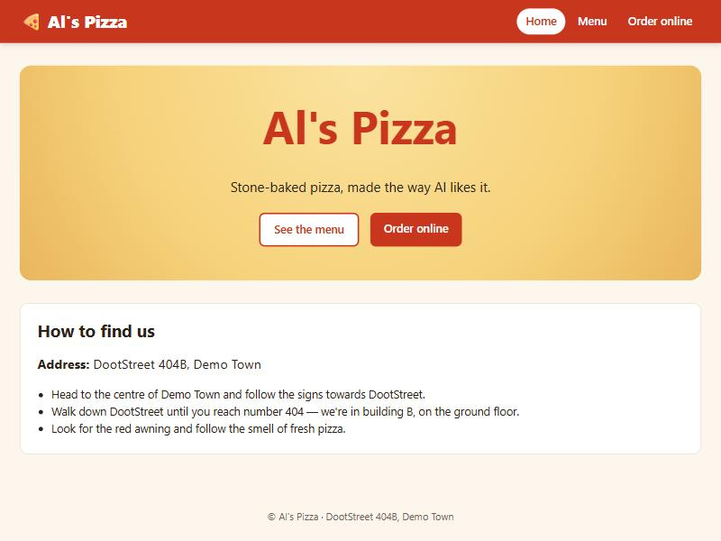
devlocalhost:5173 · Opened in Browser
Ran a command, used 6 tools
Testing the cart controls in the browser; one click didn’t seem to register, so I’m checking it.
Used 2 tools
The cart works. The earlier missed clicks came from the test’s screenshot coordinates being scaled; clicking by element reference works every time. Last, a quick look at the Menu page:
Opened, captured page
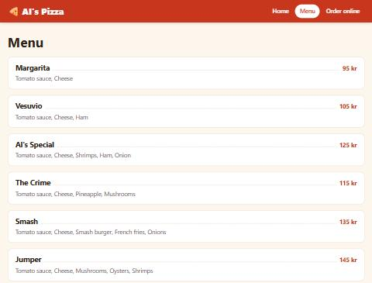
The Al’s Pizza site is built and running at http://localhost:5173 in the browser pane. It uses React 19.2, TypeScript 6, Vite 8 and React Router 8. The build and lint pass, and I clicked through all three pages to check them. In the cart, adding, changing the quantity with +/− and removing pizzas all worked, and the total updated each time.
Menu bar: It’s at the top of every page and shows “🍕 Al’s Pizza” plus links to Home, Menu and Order online. The current page is highlighted, and the Order online link shows how many pizzas are in the cart.
Home (/, the root page): Shows the pizzeria name, the address “DootStreet 404B, Demo Town”, and directions to get there.
Menu (/menu): Lists all six pizzas with their ingredients and prices.
Order online (/order):
- The cart is at the top. Each row shows the pizza’s name and how many are in the cart, with +/− buttons and a Remove button. Pressing − at 1 also removes the pizza.
- Below the cart, the pizzas are shown in a grid, each with its name, an image and an “Add to cart” button.
A few things I chose that you didn’t specify:
- Prices: You didn’t give any, so I made them up (95–145 kr). They’re in src/data/pizzas.ts, along with the pizza names and ingredients.
- Pizza images: These are drawn in code (PizzaImage.tsx) rather than using photo files, so each pizza’s picture shows its own toppings.
- Extras: I added a running total in the cart and a short footer.
- Cart is not saved: It keeps its contents when you move between pages using the menu, but reloading the page empties it.
The cart code is in src/cart/, the pages are in src/pages/, and the styling is in src/index.css. I also added .claude/launch.json so the browser pane can start the dev server. Nothing is committed yet.
To run it yourself:
npm run dev
- Edited 10 files+386−117
- pizzas.ts+64−0
- cartContext.ts+13−0
- CartProvider.tsx+36−0
- useCart.ts+10−0
- Layout.tsx+43−0
- PizzaImage.tsx+64−0
- HomePage.tsx+34−0
- MenuPage.tsx+21−0
- OrderPage.tsx+82−0
- App.tsx+19−117

